**Chapter 4 - Electrochemistry**

**All Lectures Uploaded on YouTube:**

[**https://tinyurl.com/fkm10-chemistry**](https://tinyurl.com/fkm10-chemistry)



Electrochemistry is the study and application of the fundamental principles of electrochemical reactions. Electrochemical processes include electrolysis, electroplating, and voltage cells. Electrochemistry principles include understanding the role of anode and cathode, the movement of electrons in an external circuit, and the migration of ions in an electrolyte.

**4.1. Electrochemical Cells**

Devices that convert chemical energy into electrical energy or vice versa are called electrochemical cells.

Therefore, there are two types of electrochemical cells:

1. Electrolytic Cells
2. Galvanic Cells

A physical or chemical change that occurs by itself is called a spontaneous process. Spontaneous processes do not require a source of energy to make them happen. For instance, water flows from a higher level to a lower level. Iron placed in moist air, rusts. The flow of electrons through a conductor can be obtained from a spontaneous oxidation-reduction reaction. This is the basis for how batteries work.

On the other hand, a physical or chemical change that requires a source of energy to make it happen is called a non-spontaneous process. For example, water can be made to flow from a lower level to a higher level by using a pump.

**4.1.1. Nature Of Electrochemical Process**

Electrochemical processes are oxidation- reduction reactions in which chemical energy released by a spontaneous reaction is converted to electricity or in which electrical energy is used to drive a non-spontaneous reaction. Whether an electrochemical process releases or requires energy, it always involves the transfer of electrons from one substance to another. This means that this process always involves an oxidation-reduction or a redox reaction.

**4.1.2. Electrolyte And Non Electrolyte**

When an ionic compound is dissolved in water, it splits up into its positive and negative ions, these ions are capable of conducting electricity. Such compounds are referred to as electrolytes. Substances that can conduct electricity when they are in a molten state or aqueous solution and undergo chemical changes.

Examples of electrolytes are NaCl, KCI, HCI, NaOH, etc.

A substance that cannot conduct electricity when dissolved in water or in the molten state is called a non-electrolyte.

Examples of non-electrolytes are urea, glucose, sucrose, benzene etc.

**4.1.3. Electrolytic Cells**

An electrochemical cell in which electrical energy is used to drive a chemical reaction is called an electrolytic cell.

An electrolytic cell consists of

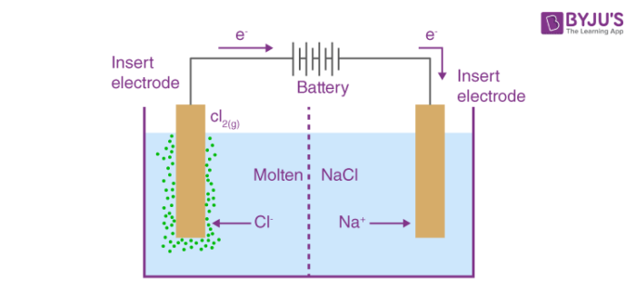

A vessel containing an electrolyte (MX)

Two inert electrodes

A battery

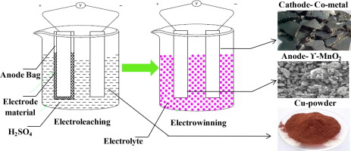

Electrons move from anode to cathode in the outer circuit, in the solution the cations move towards the cathode and anions towards anode. At the anode, anions oxidize by losing electrons. At the cathode, cations reduce by gaining electrons. This means oxidation occurs at the anode and reduction at the cathode. The electrons released by anions at the anode move in the external circuit towards the cathode. This means the movement of ions in the electrolyte and the transfer of electrons occur at electrodes in the external circuit.

**At Anode**

X- →X +1e-

**At cathode**

M+ +le- → M

**4.2. Electrolysis**

Electrolysis is the chemical process in which an electric current is passed through an electrolyte, either in its molten state or as an aqueous solution, causing a non- spontaneous redox reaction to occur. This process involves the movement of ions towards oppositely charged electrodes, where oxidation occurs at the anode and reduction occurs at the cathode. This process leads to the decomposition of the electrolyte or its components into simpler substances or elements.

**4.2.1. Electrolysis Of Molten Electrolyte**

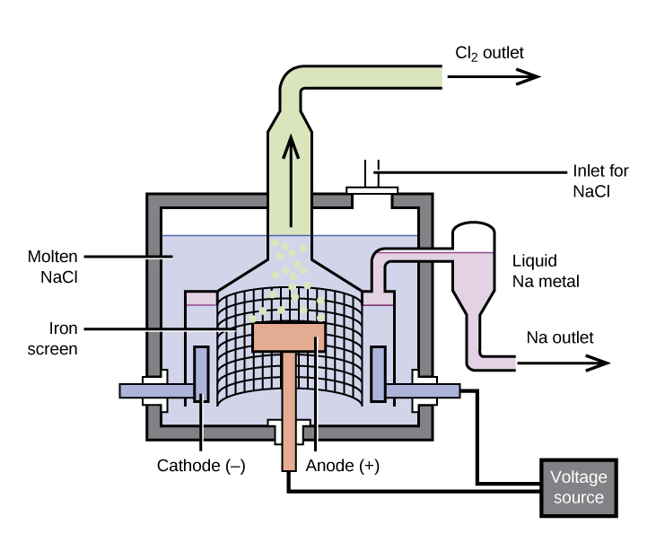

**Electrolysis Of Molten Sodium Chloride**

On a large scale, sodium metal is produced by the electrolysis of fused sodium

chloride. The electrolytic cell used in the process is called a Down's Cell. Down's Cell uses an iron cathode and carbon anode. During the electrolysis, the sodium ions are reduced at the cathode to liquid sodium metal. At the anode, the chloride ions are oxidized to chlorine gas.

At anode

2Cl- →Cl2 + 2e-

At cathode

2Na+ +2e- →2Na

(ii) Electrolysis of molten lead(II) chloride using platinum or graphite electrodes On a large scale, lead metal is produced by the electrolysis of molten or fused lead(II) chloride. An electrolytic cell is used for this purpose. Molten lead chloride is placed in the electrolytic tank and platinum, or graphite electrodes are dipped in it. The electrolysis is conducted above 327°C, which is the melting point of lead chloride.

At anode:

2Cl- → Cl2 + 2e-

At cathode:

Pb2+ +2e- →Pb

(ii) Electrolysis of molten lead(II) chloride using platinum or graphite electrodes On a large scale, lead metal is produced by the electrolysis of molten or fused lead(II) chloride. An electrolytic cell is used for this purpose. Molten lead chloride is placed in the electrolytic tank and platinum, or graphite electrodes are dipped in it. The electrolysis is conducted above 327°C, which is the melting point of lead chloride. Molten lead chloride contains free lead ions and chloride ions. During electrolysis, chloride ions move towards the anode and lead ions towards the cathode. At the electrodes following reactions occur.

Molten lead is collected at the bottom of the cathode and chlorine gas at the anode.

**4.2.2. Electrolysis Of Concentrated Aqueous Solution**

The industrial method for producing sodium hydroxide uses the electrolysis of concentrated aqueous sodium chloride, known as brine. Inert electrodes such as platinum or graphite are used. Brine contains Na⁺ and Cl⁻ ions from sodium chloride, and H⁺ and OH⁻ ions from water.

During electrolysis, chloride ions migrate to the anode where they are oxidized to form chlorine gas. Sodium ions move to the cathode but are **not** reduced to sodium metal; instead, hydrogen ions from water are discharged, producing hydrogen gas. As H⁺ ions are consumed, more water ionizes to replace them, gradually forming sodium hydroxide (NaOH) in the solution.

Finally, the resulting solution contains Na⁺ and OH⁻ ions, and evaporating the water yields pure solid sodium hydroxide.

At anode:

2Cl-→ Cl2 +2e-

At Cathode:

2H+ +2e- →H2

**4.2.3. Electrolysis Of Dilute Aqueous Solution**

Electrolysis of dilute aqueous Sodium chloride using platinum electrodes Unlike electrolysis of concentrated aqueous sodium chloride, chloride ions are not oxidized at the anode. Instead, hydroxide ions are oxidized and oxygen gas is produced at the anode. Reaction at the cathode remains the same. And hydrogen is produced at the cathode. The following reactions take place during electrolysis.

At Cathode:

4H+ + 4e- →2H2

At anode:

4OH- → 2H2O + 4e- + O2

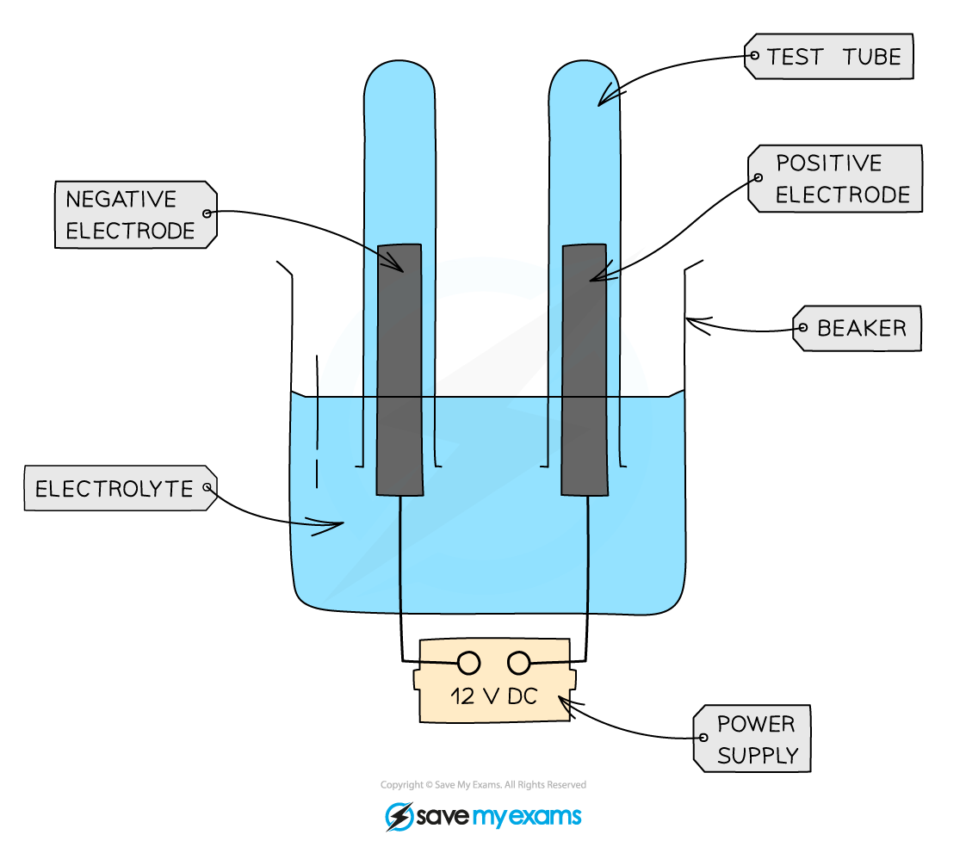

b. Electrolysis of dilute sulphuric acid using platinum electrodes

In an aqueous solution, sulphuric acid ionizes to form hydrogen ions and sulphate ions. Auto ionization of water gives hydrogen ions and hydroxide ions.

H2SO4 → 2H+ + SO2

H2O →2H+ + OH-

During electrolysis, hydrogen ions move towards the cathode and are reduced to form hydrogen. Whereas hydroxyl ions and sulphate ions move towards the anode. At the anode, hydroxyl ions are oxidized and sulphate ions remain unchanged.

At cathode:

4H+ +4e-→2H2

At anode:

4OH- →2H2O + 4e-+ O2

In the electrolysis of dilute aqueous sulfuric acid (H₂SO₄) using platinum electrodes, hydrogen gas is released at the cathode and oxygen gas at the anode.

For copper(II) sulfate electrolysis with platinum electrodes, the solution contains Cu²⁺ and SO₄²⁻ ions from the salt, and H⁺ and OH⁻ ions from water. At the cathode, both Cu²⁺ and H⁺ ions are attracted, but only Cu²⁺ ions are reduced, while H⁺ ions remain unchanged. At the anode, SO₄²⁻ and OH⁻ ions move toward it, but only OH⁻ ions are oxidized, and SO₄²⁻ ions remain unchanged.

At cathode:

2Cu2 + +4e- → 2Cu

At anode

4OH- →2H2O+O2 +4e-

In the electrolysis of aqueous copper(II) sulfate using platinum electrodes, copper metal is deposited at the cathode and oxygen gas is released at the anode. As electrolysis continues, the blue color of the copper sulfate solution gradually fades.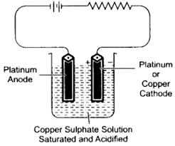

When copper electrodes are used instead of platinum, the cathode reaction stays the same, but the anode reaction changes: copper atoms from the anode dissolve into the solution as Cu²⁺ ions by giving up electrons. These electrons then flow to the cathode through the power source.

At Cathode:

Cu2+ +2e- →Cu

At anode:

Cu→ Cu2+ +2e-

During electrolysis, the copper anode is gradually consumed while the cathode gains mass as pure copper is deposited on it. Copper extracted from ores is impure, containing metals like zinc, iron, silver, and gold, and these impurities are removed through electrolytic refining. In this process, impure copper serves as the anode and pure copper as the cathode, with CuSO₄ solution containing a small amount of sulfuric acid as the electrolyte.

When electricity is passed, the anode dissolves to form Cu²⁺ ions, which migrate to the cathode where only these ions are reduced, depositing pure copper. Less electropositive metals such as silver and gold do not dissolve; instead, they settle at the bottom. The refined copper produced is about 99.5% pure.

**4.3. Electrolysis Of Halide Compound**

In the electrolysis of halide compounds, the products formed depend on whether the solution is dilute or concentrated.

For **dilute halide solutions**:

* **Anode:** Oxygen gas is produced because water molecules are oxidized, as they compete successfully with halide ions.
* **Cathode:** Hydrogen gas is produced because water is reduced to hydrogen gas and hydroxide ions.

For **concentrated halide solutions**:

* **Anode:** The halogen (chlorine, bromine, or iodine) is released since the high concentration of halide ions makes them easier to discharge than water.
* **Cathode:** Hydrogen gas is still produced due to the reduction of water.

Example: In concentrated NaCl solution, chlorine gas forms at the anode and hydrogen gas at the cathode.

**4.4. Electroplating (Deposition Using The Same Electrode)**

The electrolytic process used to deposit one metal on another metal is called electroplating. An object can be electroplated by making it cathode in an electrolytic tank containing ions of the plating metal. The plating metal is made of anode. On passing electricity through the electrolytic tanks, a thin layer of anode metal is deposited on the surface of the object.

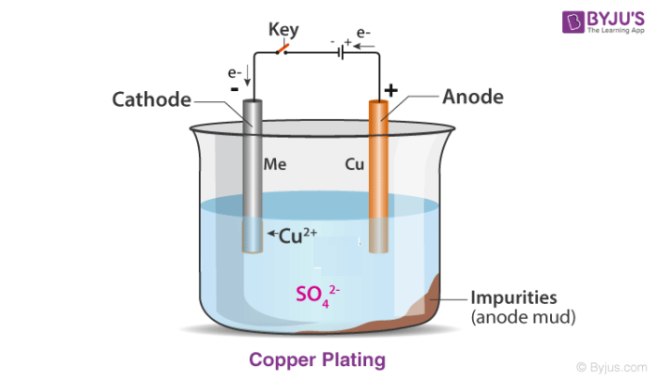

**4.4.1. Applications Of Electroplating**

Electroplating is used to protect steel objects from corrosion by coating them with metals like zinc, tin, or chromium.

**Zinc Plating:**Zinc plating uses a zinc anode and a steel cathode, with potassium zinc cyanide solution containing some sodium cyanide as the electrolyte. During electrolysis, zinc dissolves from the anode as Zn²⁺ ions and deposits onto the steel cathode. Sodium cyanide prevents hydrolysis of the electrolyte. Cyanide solutions are highly toxic and must not be released into water bodies, as they can kill fish and other animals.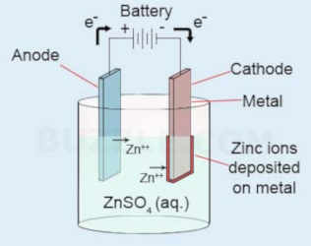

**Tin Plating:**Food cans are commonly tin-plated. Tin plating uses a tin anode and a solution of stannous sulfate (SnSO₄) as the electrolyte, with a little dilute sulfuric acid added to prevent hydrolysis. The electrolyte provides Sn²⁺ ions, which are reduced at the cathode to form a tin coating, while tin metal from the anode dissolves to replenish the ions.

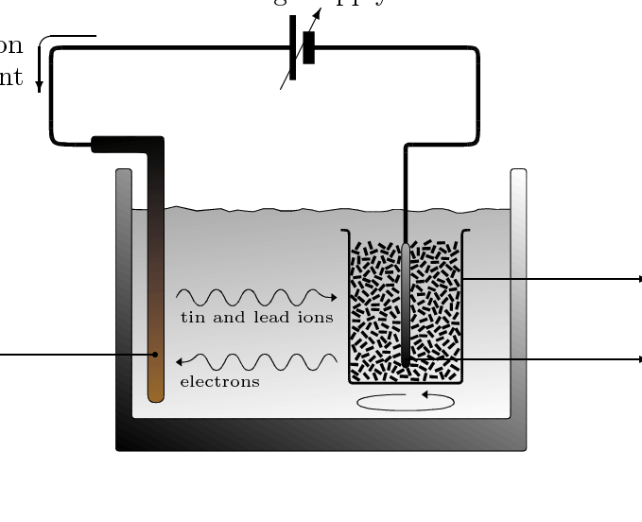

**4.5. Galvanic Cells (Daniel Cells)**

A galvanic (or voltaic) cell produces electricity from a spontaneous redox reaction. It is named after Alessandro Volta, while the first practical cell—called the Daniel cell—was constructed by Fredrick Daniel using zinc and copper electrodes.

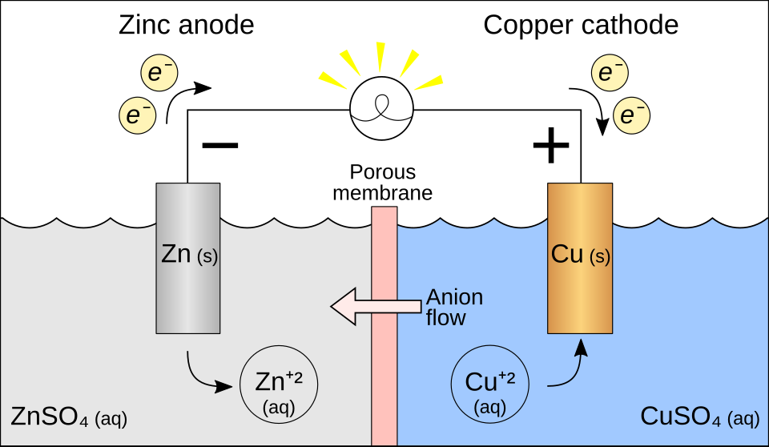

A galvanic cell contains:

* A zinc rod in 1 M ZnSO₄ solution
* A copper rod in 1 M CuSO₄ solution
* A salt bridge (inverted U-tube with an inert electrolyte like KCl) that allows ion movement without reacting with the solutions
* A voltmeter to measure current

Each metal in its salt solution forms a half-cell, and the two half-cells together make the Daniel cell. When the circuit is completed, electrons flow from zinc to copper. Zinc acts as the **anode** and copper as the **cathode**.

**4.5.1. Reactions In A Daniel Cell**

Zinc undergoes oxidation more readily than copper, so Zn atoms form Zn²⁺ ions and release electrons at the anode. Copper(II) ions in the solution accept electrons at the cathode to form copper metal. These are the half-cell reactions:

* **Anode (oxidation):** Zn → Zn²⁺ + 2e⁻
* **Cathode (reduction):** Cu²⁺ + 2e⁻ → Cu

**4.6. Electrochemical Series**

The electrode potential (E°) of a metal is its tendency to be oxidized or reduced when placed in a solution of its own ions, and it is measured in volts. Electrode potentials are determined using the standard hydrogen electrode, and IUPAC represents them as **reduction potentials**.

The **electrochemical series** is a table of elements arranged in order of increasing reduction potentials. Metals higher in the series have lower reduction potentials and more readily lose electrons, making them more reactive. In a voltaic cell, the metal with the lower reduction potential acts as the **anode**, while the one with the higher reduction potential acts as the **cathode**.

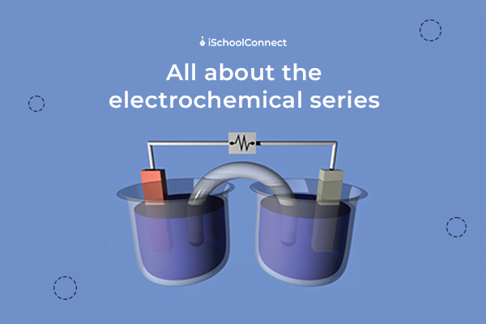

The series also helps predict products formed during electrolysis:

* **At the cathode**, cations gain electrons. The ion lower in the electrochemical series (less reactive) is preferentially reduced. For example, in a solution containing Na⁺ and H⁺, hydrogen gas forms because hydrogen is lower in the series.
* **At the anode**, anions lose electrons. Halide ions (Cl⁻, Br⁻, I⁻) are discharged before hydroxide ions unless they are absent. For example, in concentrated NaCl solution, chloride ions produce chlorine gas.

In **dilute NaCl solution**, OH⁻ ions are discharged instead of Cl⁻ despite Cl⁻ being lower in the series. This occurs due to:

1. **Concentration effect:** Dilute NaCl contains far fewer Cl⁻ ions than OH⁻ ions from water.
2. **Overpotential of chlorine:** Oxidizing Cl⁻ to Cl₂ requires higher overpotential than oxidizing OH⁻ to O₂, making OH⁻ discharge more favorable.

**4.7. Battery-A Source Of Electrical Energy**

A battery is a single galvanic cell or a combination of galvanic cells joined in series, producing electrical energy through a redox reaction. During operation, the anode undergoes oxidation and releases electrons, which flow through the external circuit to the cathode, where they reduce an oxidizing agent. Common battery types include dry cells, storage cells, and mercury batteries.

**Fuel Cell:** A fuel cell is a special galvanic cell that converts the chemical energy from the reaction of hydrogen and oxygen directly into electrical energy. Hydrogen burns in oxygen to form water in an exothermic reaction:

2H₂ + O₂ → 2H₂O + heat

In a hydrogen–oxygen fuel cell, porous carbon electrodes containing platinum act as catalysts, and the middle compartment contains hot aqueous KOH. Hydrogen enters the anode compartment and oxygen enters the cathode compartment.

* **Anode reaction:** 2H₂ + 4OH⁻ → 4H₂O + 4e⁻
* **Cathode reaction:** O₂ + 2H₂O + 4e⁻ → 4OH⁻
* **Net reaction:** 2H₂ + O₂ → 2H₂O

Electrons produced at the anode flow through the circuit to the cathode. The cell provides about 0.9 V and operates at high temperatures, causing the produced water to evaporate; the water can be condensed.

**Uses:** Hydrogen–oxygen fuel cells have been used in the American space program, and the condensed water is used by astronauts.

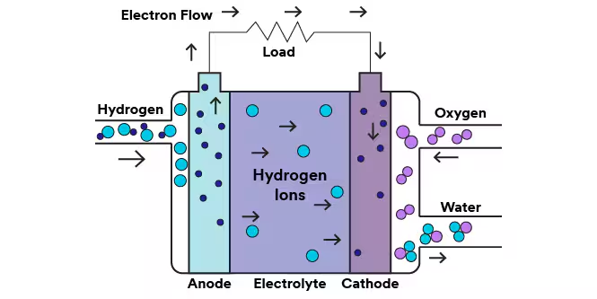

**4.7.1. Advantages And Disadvantages Of Fuel Cells**

Hydrogen–oxygen fuel cells offer several advantages: they are highly efficient because they convert fuel directly into electricity with minimal waste, and they are a clean energy source that produces only water vapor. They are also reliable due to having no moving parts, require little maintenance, and have a long lifespan. The hydrogen and oxygen used can be obtained from renewable sources. In contrast, gasoline engines release pollutants such as CO₂ and oxides of nitrogen and sulfur, contributing to smog and health problems, and rely on non-renewable fuels.

However, fuel cells also have disadvantages. Hydrogen is extremely flammable and explosive, requiring careful handling and making transportation difficult. Additionally, producing hydrogen through water electrolysis is very costly.

